**Grazioso Salvare Dashboard**

Overview

Grazioso Salvare's dashboard is a fully functional web application designed to visualize and interact with a MongoDB database of rescue animal data. The dashboard allows users to filter and categorize data related to various types of rescue operations.

Features

Data Visualization: Displays rescue animal data through interactive graphs and charts.

Filtering Options: Users can narrow down searches by animal type, breed, geolocation, and age.

CRUD Operations: Provides functionality for creating, reading, updating, and deleting records.

Technologies Used

Frontend: HTML, CSS, JavaScript

Backend: Python (Flask or Django)

Database: MongoDB

Libraries: Chart.js (for graphs), Flask-PyMongo (for MongoDB interaction), etc.

**Required Functionality of the Project**

The Grazioso Salvare dashboard provides users with a comprehensive interface for managing and visualizing rescue animal data. The key functionalities include:

* **Data Visualization:** Users can view graphs and charts representing various data metrics, such as the number of rescues by type or breed distribution.
* **Filtering Options:** The dashboard allows users to filter data based on specific criteria, such as animal type, breed, age, and location.
* **CRUD Operations:** Users can create, read, update, and delete records directly from the dashboard, ensuring data is current and accurate.
* **User-Friendly Interface:** The dashboard features an intuitive design that facilitates easy navigation and interaction.

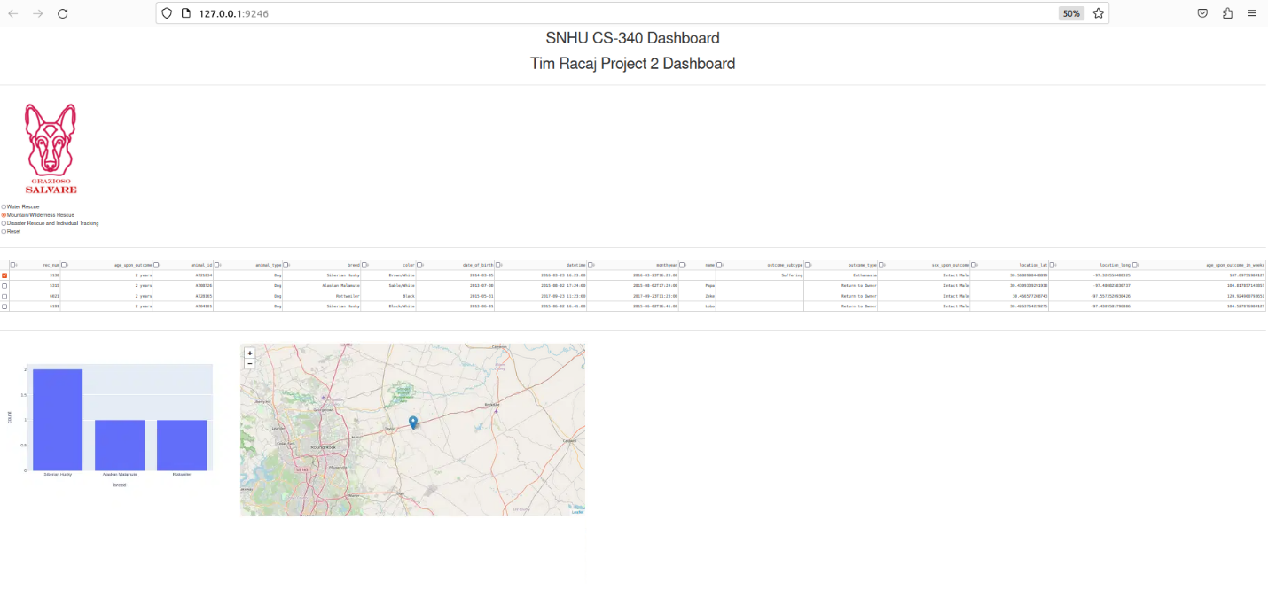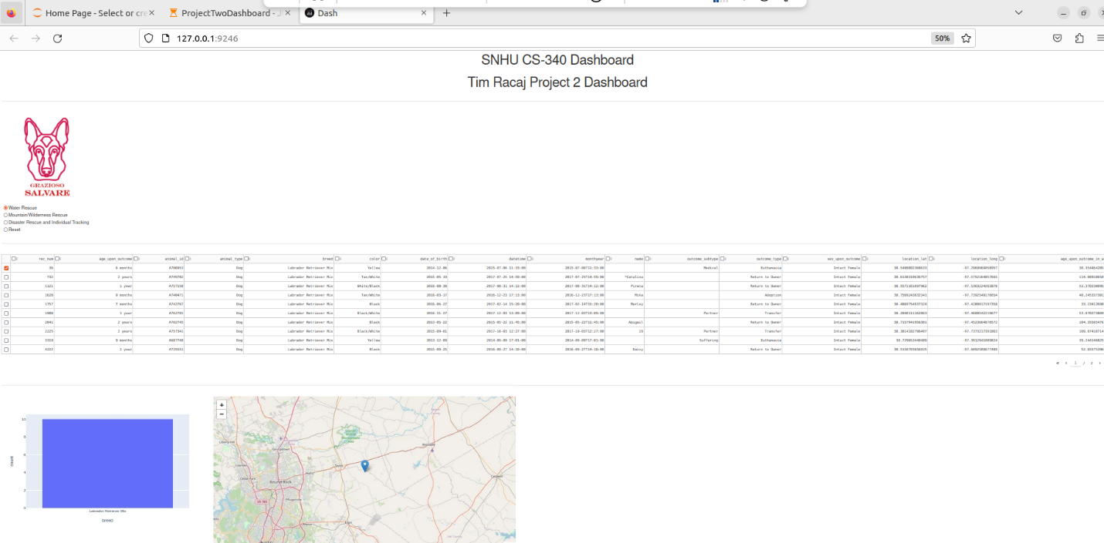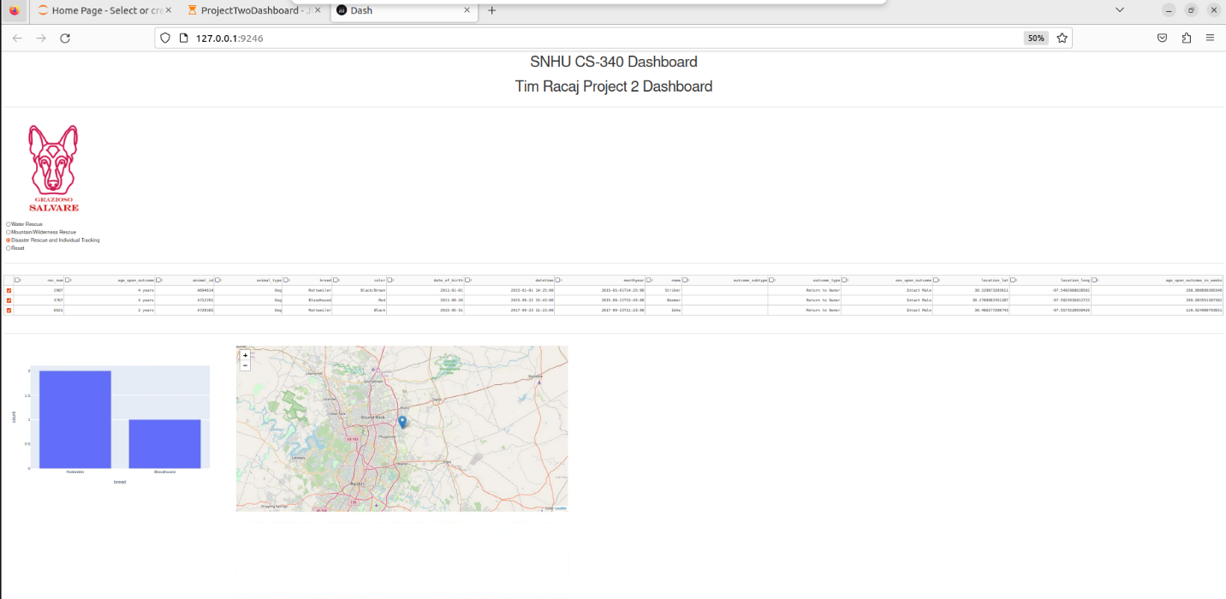

**Rationale for Tool Selection**

* Flask: Chosen for its flexibility and ease of use, allowing for quick development and the ability to scale as needed.
* MongoDB: Selected for its NoSQL architecture, which is well-suited for handling unstructured data, enabling dynamic queries and easy updates.
* Chart.js: Provides a simple yet powerful way to visualize data with a variety of chart types, enhancing the user experience.

**MongoDB as the Model Component**

MongoDB was used due to its capacity for handling large volumes of unstructured data and its flexibility in data representation. The following qualities make MongoDB suitable for interfacing with Python:

* Document-Oriented Storage: Data is stored in a flexible, JSON-like format (BSON), allowing for easy adjustments and updates.
* Scalability: MongoDB scales horizontally, making it suitable for applications expecting to grow in data volume.
* Rich Query Capabilities: Supports complex queries, aggregations, and indexing, making data retrieval efficient.
* Integration with Python: Using Flask-PyMongo, the integration process is seamless, enabling straightforward database operations within Python code.

Dash Framework

The Dash framework provides a structure that combines both the view and controller aspects of web applications. It allows developers to create interactive web applications using pure Python code. The benefits of Dash include:

* Declarative Syntax: Simplifies the creation of complex dashboards with a clear and concise code structure.
* Interactivity: Easily integrates user inputs to update visualizations dynamically.
* Integration with Plotly: Provides access to advanced graphing capabilities, enhancing data visualization options.

**Project Completion Steps**

1. Initial Planning: Defined the project scope and outlined functionalities.
2. Setting Up the Development Environment: Installed necessary tools and libraries.
3. Database Design: Established the MongoDB schema for storing rescue animal data.
4. Frontend Development: Designed the user interface using HTML, CSS, and JavaScript.
5. Backend Development: Created endpoints in Flask to handle data requests and manage CRUD operations.
6. Integration of Chart.js: Implemented graphs for data visualization.
7. Testing and Deployment: Conducted thorough testing of functionalities and deployed the dashboard.

**Challenges Encountered**

* Data Integration: Initially faced issues with importing data into MongoDB. This was overcome by carefully reviewing the import process and ensuring proper formatting of the data files.
* Dynamic Filtering: Implementing the filtering functionality proved challenging due to complex query requirements. This was resolved by creating helper functions to build dynamic queries based on user input.
* User Interface Design: Ensuring the UI was user-friendly took several iterations.

**Resources and Links**

* Flask Documentation: Flask
* MongoDB Documentation: [MongoDB](https://www.mongodb.com/docs/)
* Chart.js Documentation: Chart.js
* Dash Documentation: Dash